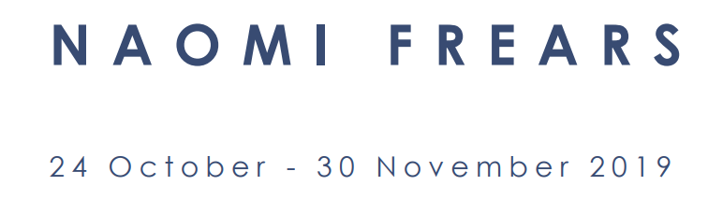

“In every single piece of work I’m trying things I’ve never tried before, in a colour I’ve never used, looking at it a certain sort of way.”
Naomi Frears
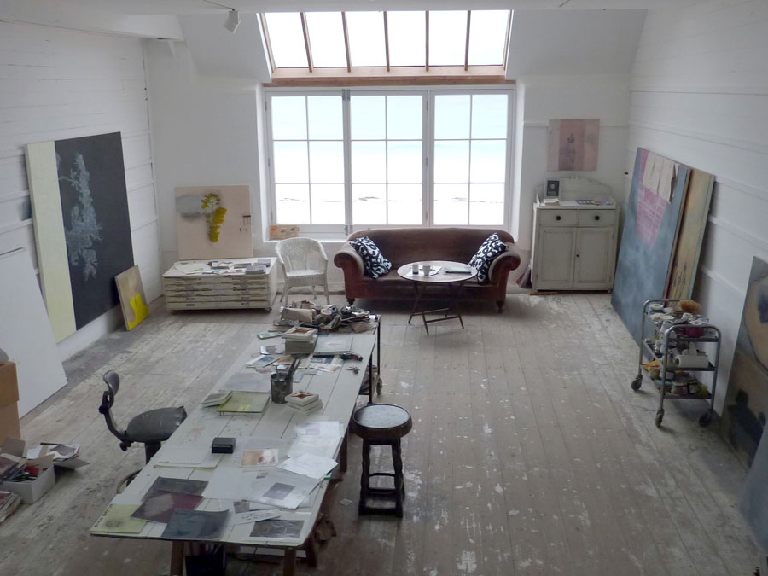
Naomi’s Studio at Porthmeor Studios that was once occupied by Francis Bacon

Beaux Arts showcases a highly anticipated collection of new paintings by St Ives based contemporary artist, Naomi Frears.
She works in the one of the famous Porthmeor Studios once occupied by Francis Bacon who described it as “the best room in St Ives”, that previously shared its light with other renowned artists including Wilhelmina Barns-Graham, Breon O’Casey and Patrick Hughes.
Other Porthmeor studios have also been occupied by Peter Blake, Terry Frost, Ben Nicholson Patrick Heron, Sandra Blow and Karl Weschke.
Frears’ exhibition follows the celebrated retrospective Four Giants of British Modernism at Beaux Arts London which featured the four pioneers of British Abstract art, Terry Frost, Patrick Heron, Peter Lanyon and William Scott. Like these modern innovators, Naomi Frears is a younger artist, from the St Ives School, working with a new and original process.
“‘sailed into headwinds’ a Francis Bacon saying. When a painting is lost beyond salvation, I send it to the framers so they can rescue the canvas stretcher”
Naomi Frears

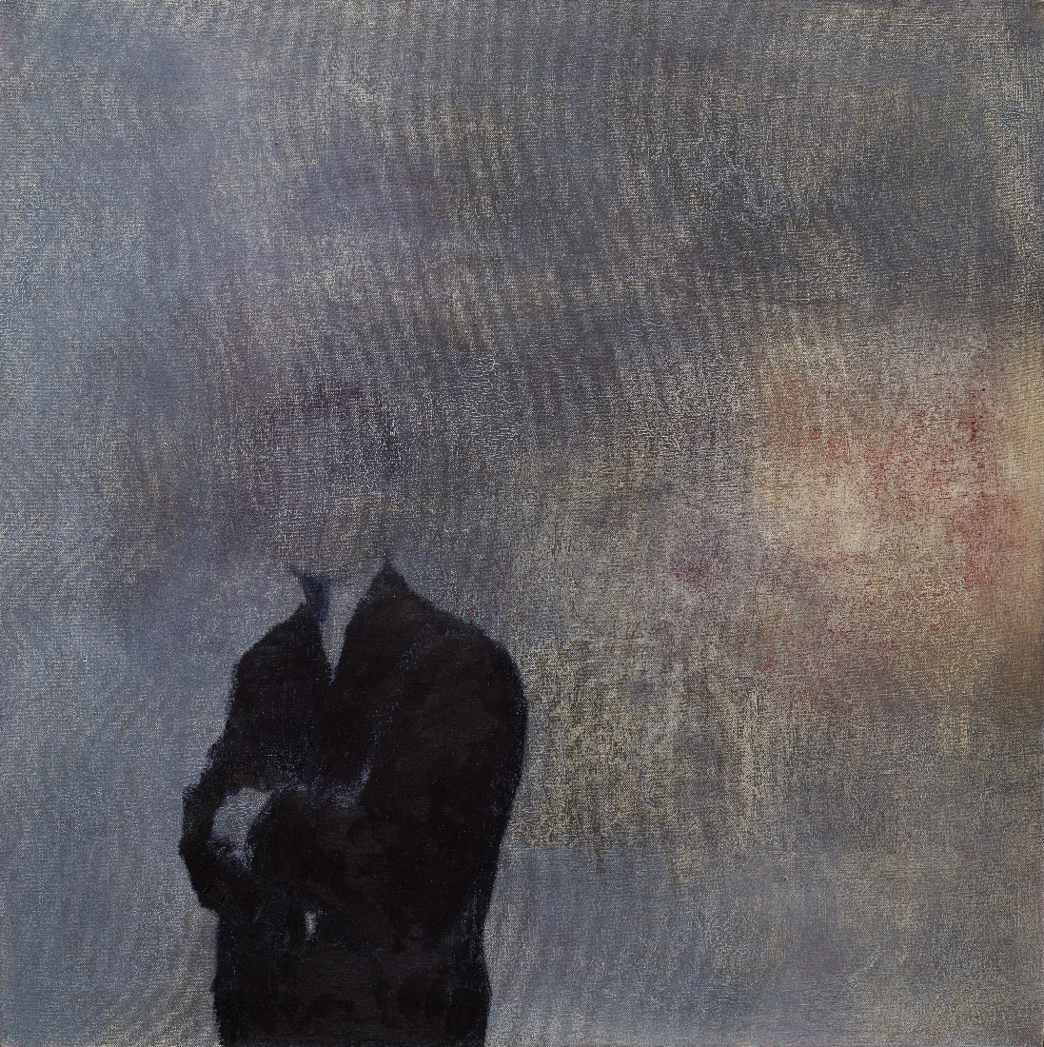
He looks like you, 2019, oil on canvas, 61 x 61 cm

“For those who recognise her work’s distinctive atmospheric qualities, Naomi’s paintings are always in conversation with one another. Juxtaposition – as significant between the paintings as it is fundamental within them – has a dissonant quality here.”
Alice Spawls, Catalogue Essay 2019
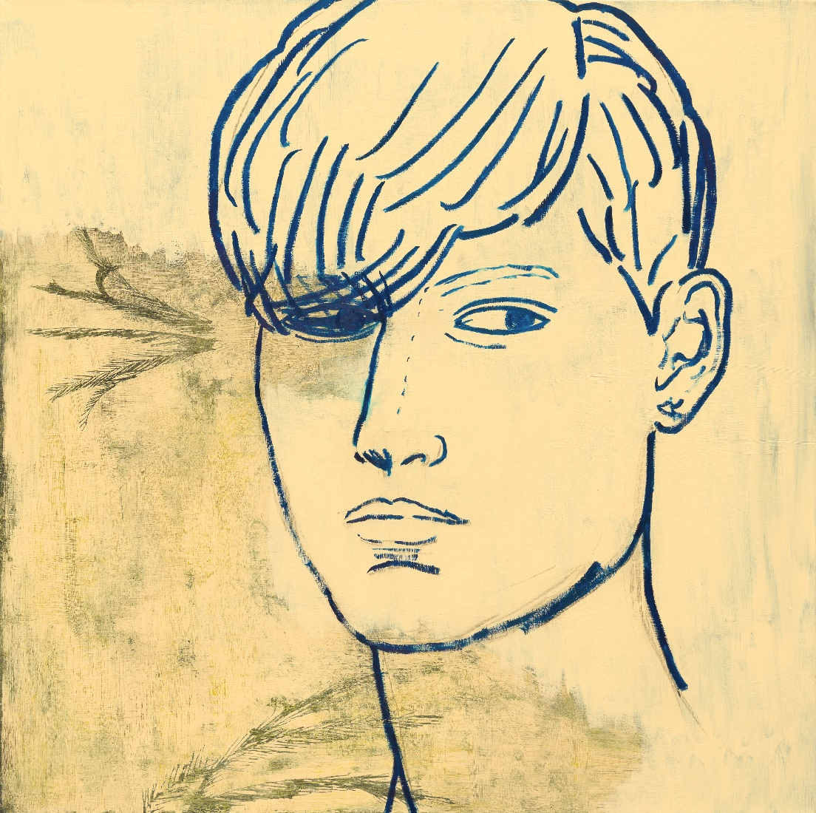
As well as painting, Naomi is a film maker in her own right. Her latest project entitled All Going Nowhere Together was commissioned by CAST (Cornubian Arts & Science Trust) founded by curator, writer and wife of Nicholas Serota, Teresa Gleadowe.

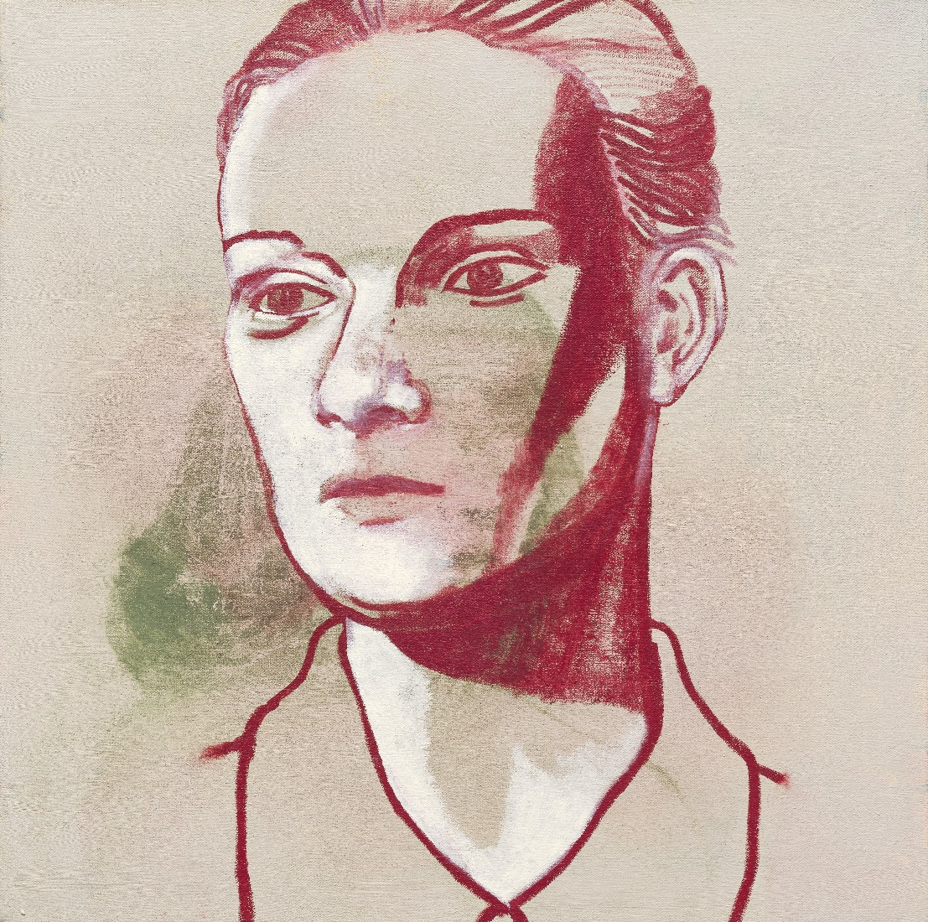
“Battle to save the soul of a painting”
Naomi Frears

“If a painting does not live you have to be brave”
Naomi Frears
“the day I lost a painting I said to a friend at least “I am alive””
Naomi Frears
“I’m not making cakes”
Naomi Frears

